**HAZELWOOD v. KUHLMEIER (1988)**

In May 1983, students in the Journalism II class at Hazelwood East High School in St. Louis, Missouri, created the final edition of the school paper, the Spectrum. Before publishing the paper, they submitted it to their advisor, Howard Emerson, so he could review it. Emerson was new to the job, so he followed the procedures of the previous advisor. Those guidelines required him to give Principal Robert Reynolds the opportunity to review the paper before it was published.

When Principal Reynolds reviewed the paper, he found two articles that concerned him. The first dealt with the issue of teen pregnancy. It included comments from pregnant students at the school. To protect their privacy, names were not given. However, when Reynolds read the article, he realized that the details in the article would make it easy for other students to identify the pregnant teens. He also noticed that the article mentioned sex and birth control, which he did not think that students in ninth grade should have been learning about. The second article addressed the issue of divorce. Like the first article, this one included personal information. One student, whose parents were divorced, made negative comments about her father. She said that her father was always out with his friends and that her father didn't spend enough time with the family. Principal Reynolds was troubled by the fact that the father had not been given a chance to defend himself by responding to his daughter's comments.

Reynolds wanted the journalism students to modify the articles. However, it was almost the end of the school year. If they took the time to revise, they would miss the deadline for publishing the newspaper. If that happened, the other students might never get to read the paper. He felt like he had to act quickly, so he told Emerson to delete the two pages with the offending articles and publish the rest of the Spectrum. He told his supervisors about this decision and they agreed with him.

**KEY TERMS**

**Violated**: To break or disregard (a law or promise, for example)

**Censor**: To examine and remove information to prevent others from viewing it

**Interfere**: To create a distraction or obstacle

**Appeal**: To request that a higher court review a case

**Reverse**: To overturn the decision of a lower court and decide the case differently

The students had worked hard on the paper and felt that they had followed proper journalism procedures. If they had been approached about the problems, they may have been able to correct them. They were upset to find out instead that two pages, which included a number of nonoffensive articles, had been deleted. They felt that their First Amendment rights had been violated. They took the case to the U.S. District Court for the Eastern District of Missouri. The district court ruled against the students, but they appealed their case. The Court of Appeals for the Eight Circuit court agreed with the students and reversed the decision of the lower court. The school then appealed that ruling to the US Supreme Court, which agreed to hear the case. In determining whether or not students' rights were violated, it would consider whether or not the student newspaper was a public forum and whether the First Amendment "requires a school affirmatively to promote particular student speech."

The Supreme Court ruled against the students in a 5-3 decision. Justice White wrote the majority opinion, concluding that the First Amendment does not prevent school officials from exercising reasonable authority over the content of school-sponsored publications.

The majority opinion first considered whether school-sponsored student newspapers are public forums. If they were public forums, school officials would not be allowed to exercise editorial control over the content of the paper.  Referring to Supreme Court precedent, the decision noted that school facilities are only considered to be public forums when school authorities have “opened those facilities ‘for indiscriminate use by the general public.’” If the facilities are used for other purposes, however, they do not constitute a public forum, and “school officials may impose reasonable restrictions on the speech of students.” The school newspaper in this case was not open to the unlimited contribution of students, teachers and other members of the community, but was instead published as part of the curriculum of a journalism class. Therefore, its primary function was for educational purposes, and the newspaper did not constitute a public forum.

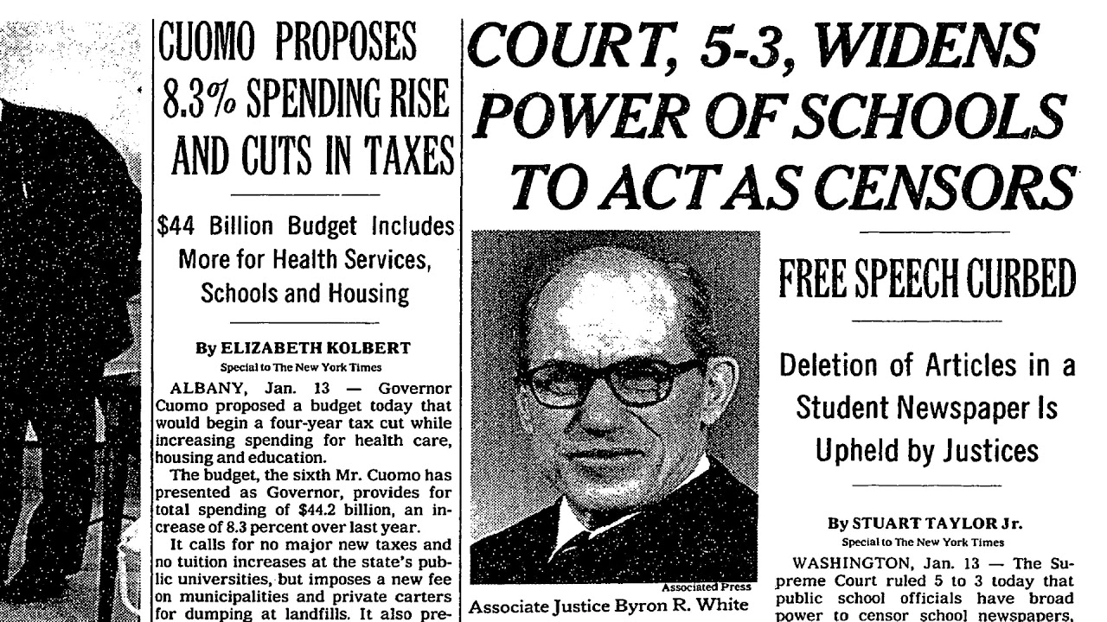The Court then addressed the question of whether the First Amendment “requires a school affirmatively to promote particular student speech.” They concluded that it does not. The First Amendment rights of students in public schools are not necessarily equal to those of adults outside of schools.  “A school need not tolerate student speech that is inconsistent with its ‘basic educational mission, even though the government could not censor similar speech outside the school.”

The Court decided that the issues involved in this case differ from those the Court ruled on in *Tinker v. Des Moines*. In that case, the Court questioned whether school officials could “silence a student’s personal expression that happens to occur on the school premises.” *Hazelwood*, however, forced the Court to consider the extent of school officials’ control over “school-sponsored publications … and other expressive activities that students, parents, and members of the public might reasonably perceive to bear the [approval] of the school.” Tinker asked whether schools must tolerate certain student speech, while this case questioned whether schools must endorse student speech.

The Supreme Court concluded that the First Amendment does not force schools to endorse student speech in their school-sponsored publications. School officials have authority and control over these publications in order to ensure that “participants learn whatever lessons the activity is designed to teach, that readers or listeners are not exposed to material that may be inappropriate for their level of maturity, and that the views of the individual speaker are not erroneously attributed to the school.” Therefore, as long as the editorial control of school officials was “reasonably related to legitimate [educational] concerns” such as those mentioned above, it did not offend the First Amendment.

**QUESTIONS:**

1) What concerns did Principal Reynolds have regarding the two articles? Were these legitimate concerns?

2) What might have been other ways that the principal could have handled the situation?

3) Do you think that Principal Reynolds was justified in deleting the two pages of the paper? Should a principal be able to censor student newspapers? If so, under what conditions?

4) What rights did the students believe had been violated?

5) What might have been other steps that the students could have taken other than filing a lawsuit?

6) Should a principal or other school authority be able to silence other forms of student speech? If so, under what conditions? How does speech by an individual student differ from speech by the school newspaper?

7) How did the Supreme Court rule? In your own words, what was their reasoning?

8) Both Tinker v. Des Moines and Hazelwood v. Kuhlmeier involved the 1st Amendment in schools, but they were decided in opposite ways. What makes the cases different?

9) Should standards in schools be different from standards in the "real world?" Why or why not? Write a couple of sentences to explain your position.